Chapter 15, Problem 38.

Find f(t) given that:

(a) 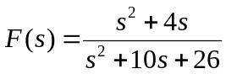
(b) 